WELCOME TO STRANRAER GOLF CLUB
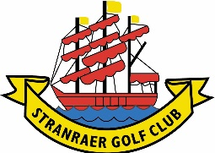
New Member Information Pack

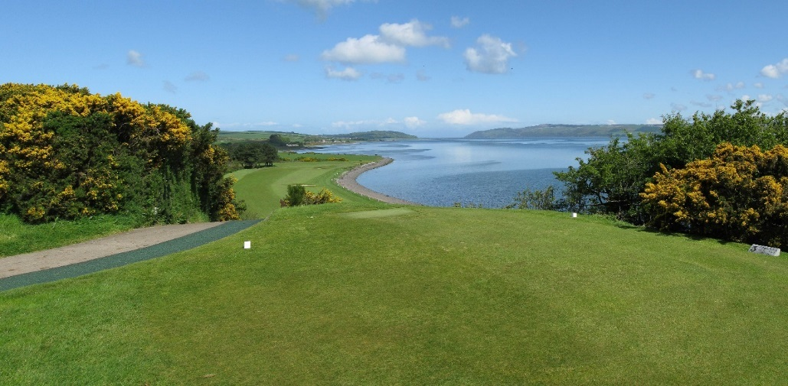

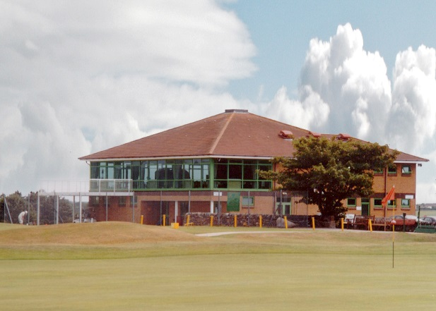

2020
www.stranraergolfclub.net
01776 870245

Contents
1.0 Clubhouse 3
1.1 Club 3
1.2 Office Bearers for 2020 3
1.3 Communication 3
1.4 Clubhouse Hours 3
1.6 Dress Code 4
1.7 Mobile Phones 4
1.8 Lockers 4
1.9 Caddy Shed 5
2.0 Golf 5
2.1 Tee Booking System 5
2.2 Competitions 5
2.3 Handicaps 5
2.5 Greens 5
2.6 Care of the Course 6
2.7 Local Rules (updated in 2019) 6
3.0 Members Benefits 7
3.1 Four Club Agreement Reciprocal Golf: 7
3.2 Association of James Braid Golf Courses: 7
3.3 Functions 7
4.0 Communication 7
4.1 Twitter, Facebook & Stranraer Golf Club App 7
4.2 Website: 7
4.3 Emails 7
4.5 Useful Information 8

1.0 Clubhouse

1.1 Club

Stranraer Golf Club was established in 1905 with a course on the west side of Stranraer. The land was sequestrated during the Second World War and the current site not open for play until 1952.
The Club is not for profit unincorporated organisation. The Board of Governance is vested in the Management Committee and is made up of a President, Vice President, Captain and Vice-Captain, Ladies Captain and Vice-Captain, Past Captain, Ladies Past Captain and five ordinary members of the Club.

1.2 Office Bearers for 2020
President; Andy Gibson
Vice President: - Val Plant
Captain: - Roderick Davidson
Vice-Captain:- John McMonies
Lady Captain: - Beryl Niven
Past Captain: - Phillip Wilson

Committee Members:
Andy Gibson, Douglas Compton, Alison Burns, Malcolm Smith, Jackie Hart, Andrew Hastie
Co-opted members:- Jim Arnott

Club Secretary: - Lawri Shanks
Assistant Secretary: Kalli Greer
Match Secretary: - Robert Allison

Office Hours:
Summer
Mon- Sun 09:00 to 13:00
Winter
Mon- Fri 09:00 to 13:00

1.3 Communication

Please ensure that all your personal details are always kept up to date with any alterations and amendments given to the secretariat to maintain accuracy.
Sign up to Twitter and Facebook for regular updates and information.

1.4 Clubhouse Hours

Summer hours
 | CLUBHOUSE | BAR | CATERING
Monday | 07:00 – 23:00 | 10:00-23:00 | 07:30 – 18:00
Tuesday | 07:00 – 23:00 | 10:00-23:00 | 07:30 – 20:00
Wednesday | 07:00 – 23:00 | 10:00-23:00 | 07:30 – 20:00
Thursday | 07:00 – 23:00 | 10:00-23:00 | 07:30 – 20:00
Friday | 07:00 – 23:00 | 10:00-23:00 | 07:30 – 20:00
Saturday | 07:00 – 23:00 | 10:00-23:00 | 07:30 – 20:00
Sunday | 07:00 – 23:00 | 10:00-23:00 | 07:30 – 20:00

Winter Hours
 | CLUBHOUSE | BAR | CATERING
Monday | 07:30 – 16:00 | 10:00 – 14:00 | 08:00 – 14:00
Tuesday | 07:30 – 17:00 | 10:00 – 17:00 | 08:00 – 17:00
Wednesday | 07:30 – 17:00 | 10.00 – 17:00 | 08:00 – 17:00
Thursday | 07:30 – 17:00 | 10.00 – 17:00 | 08:00 – 17:00
Friday | 07:30 – 17:00 | 10:00 – 17:00 | 08:00 – 17:00
Saturday | 07:30 – 19:00 | 10:00 – 23:00 | 08:00 – 17:00
Sunday | 07:30 – 19:00 | 10:00 – 23:00 | 08:00 - 17:00

During the winter season the clubhouse may close 30 minutes after the last car leaves the Car Park. Members are requested to contact the Stewardess for special arrangements outside the core times.

1.6 Dress Code

Clubhouse
Smart casual wear. No football/rugby/motor racing colours. Jeans/denims are permitted in the clubhouse.
Footwear worn on the course is only permitted in designated ground floor areas of the Clubhouse.
All weatherproof garments must be removed in the lounge/dining room. Golf equipment, rucksacks and holdalls are not allowed in the lounge/dining room.
Caps and visors must not be worn in the lounge/dining room.
Course:
Smart casual wear. Golf shoes should be worn.
No football/rugby/motor racing colours.
No football/rugby style shorts

1.7 Mobile Phones

Mobile phones should be kept on silent when in the Clubhouse for the respect of other members.

1.8 Lockers

Lockers where available can be acquired by members for an annual rental fee of £35. Currently there is a locker deal which allows members to pay 4 years rental for £100. For further information contact the office.

1.9 Caddy Shed

Keys are available for the shed. Boxes are available to rent for £10 per annum. If you leave your trolley including powered trolleys, please note that the clubs accepts no responsibility for any damage or loss.

2.0 Golf

2.1 Tee Booking System

The Club operates a booking system on the BRS Golf App. To register for this, contact the office.

2.2 Competitions

Please check the notice boards and website for particulars of competitions for gentlemen, ladies and juniors. www.stranraergolfclub.net

2.3 Handicaps

In order to compete in a club competition, you must have a valid and up to date handicap. Members transferring in or players who are members of other clubs but wish their “home” club nominated as Stranraer should obtain their latest handicap certificate from their former club and post/hand it to the Club for the attention of the Match Secretary.
To obtain a new handicap, or to reinstate a lapsed handicap, three cards must be handed in. these must be clearly marked “FOR HANDICAP”. All cards must be marked and signed by a member who has a valid handicap. The cards must be for rounds over a measured course i.e. yellow, white or red (ladies only) tees may be used.

CDH (Central database of Handicaps)
Stranraer feeds scores into the CDH programme. Members should be aware of their CDH number (obtained from the handicap list on Master Scoreboard app/website). Please ensure you provide your CDH number when entering competitions “away” from home. This keeps your handicap up to date.

2.5 Greens
Head Green Keeper: Andrew Ewing
Assistant Head Green Keeper: Graeme Smith
Green keeper: Liam Harvey

Any comments on the course or greens should be directed through our Greens Convener, currently Malcom Smith.
During the winter we sometimes have specific conditions of play in operation and these will be notified via the club notice board.

2.6 Care of the Course

Notices are displayed during inclement weather regarding the use of Buggies and are the sole discretion of the Head Green keeper or Green keeper on duty.
Pitch Marks
Please remember to replace all divots and all pitch marks should be repaired promptly. If you happen to come across some that are not of your making please be courteous and repair them.

2.7 Local Rules (updated in 2019)

1.Out of Bounds:- Boundaries are as follows:
All fences, hedges and lines of white posts round the perimeter of the course.
The shoreline of Loch Ryan- this is defined by the line of white posts at the 5th Hole and where applicable at the 14th Hole. The practice ground bounded by the line of white posts to the right of the 3rd Hole and the left of the 11th & 12 Holes. The area between the 9th and 18th Holes which contains the practice area and is bounded by white posts.
The gate at the back of the 11th green is an integral object
2. Penalty Areas
All burns and ditched are Penalty Areas; Rule 17 Applies.
Red posts at the burn on the 2nd and 3rd 12th, 15th & 16th holes and the open ditch to the left of the 5th Hole indicate the extent of the Red Penalty Areas. Rule 17.1(d) applies
Yellow posts at the burn approach to the 3rd green indicate a Yellow Penalty Area. Rule 17.1(d) applies.
Note:- Timber sides of the burns and bridges and culverts are integral parts of the course and are NOT obstructions.
3. Surfaced Adjacent to 9th Green
This road is an integral part of the course and NOT an obstruction.
4.Road (15th and 16th Holes)
If a ball lies on or within the tracks of the road leading to the shore and which crosses the 15th and 16th Holes, the player may lift and drop, without penalty, behind the road keeping the point between themselves and the hole. Rule 16.1(a) applies
5.Lower Putting Green (11th Hole)
The lower green is considered a wrong green and relief must be taken under Rule 13.1 (f)
6.Immovable Obstructions Close to Putting Green
The player may take relief under Rule 16.1b if an immovable obstruction is:
On the line of play and is; within two club-lengths of the putting green and within two club-lengths of the ball.

3.0 Members Benefits

Stranraer Golf Club members enjoy various benefits from their membership package.

3.1 Four Club Agreement Reciprocal Golf:

Full Members of Stranraer GC can if pre-arranged avail themselves of complementary golf at Turnhouse GC (Edinburgh), Helensburgh GC and Craigiehill (Perth) Contact numbers available from the secretary.

3.2 Association of James Braid Golf Courses:

Stranraer is a member of the Association of James Braid Golf Courses, significant as we are the last designed by the illustrious five times Open Champion and course designer James Braid. The advantage of being a member of the Association is that members of clubs can play at all other member clubs at a reduced green fee, subject to tee availability. Courses either have to have been designed, re designed or altered to be able to join. Tee times can be arranged on request. Proof of membership must be shown at time of play. A full list of current courses is available on our website.

3.3 Functions

The clubhouse is available for all members and their immediate families for parties, dinners and functions. We also cater for weddings although the strict Licensing Laws require that this is only available to members.

4.0 Communication

4.1 Twitter, Facebook & Stranraer Golf Club App

Follow us on Twitter for course updates and up to date information.
Our Twitter name is @GolfStranraer
Stranraer Golf Club’s Facebook user name is Stranraer Golf Club.

4.2 Website:

Our website address is www.stranraergolfclub.net . This is where you will find all you need to know about the Club. There are historical facts and photographs from days of yore. Also information on the Club, the course, competitions and fixtures. There are also links to other useful sites.

4.3 Emails

Members will be kept up to date on club matters and news via e-mail. You are encouraged to sign up so that we can engage with you as quickly as possible of new or impending information. Please keep the secretary informed of any changes to your contact details.

4.4 Useful Information

Telephone Numbers | Office: 01776 870245 Option 1  Clubhouse/Bar: 01776 870245 Option 2
Website Address | www.stranraergolfclub.net
E-mail Addresses | stranraergolf@btconnect.com
Twitter | @GolfStranraer
Facebook | Stranraer Golf Club
List of Office Bearers | President: Andy Gibson  Green Convener: Malcolm Smith  Vice President: Val Plant  Captain: Roderick Davidson  Vice-Captain: John McMonies  Lady Captain: Beryl Niven  Committee Members  Past Captain:- Phillip Wilson  House Convener: Douglas Compton  Alison Burns, Andrew Hastie, Jackie Hart, Malcolm Smith, Douglas Compton  Junior Convener: Val Plant  Co-opted members:-  Jim Arnott  Secretary  Lawri Shanks  E-mail: stranraergolf@btconnect.com  Assistant Secretary  Kalli Greer  stranraergolf@btconnect.com  Stewards  John & Margaret Ann McCulloch

