Newsletter No.2/18
Around the Greens
Green Speed and Quality
I realise there is some frustration within the golfing membership relating to the greens condition; it is the same frustration shared by the Committee and Greens Staff. This issue was caused over the winter and the staff are working hard to make improvements. Unfortunately the new chemical replacement for ‘cyrene’ (the banned pesticide for leather jackets) is not as effective as hoped, with some or the greens looking pitted with some small brown holes. Further treatments will be used to reduce the re-infestation later in the year.
The weather is at last improving thanks to a little more heat and some sunshine, and has accelerated the much needed growth on the greens, some surfaces still need more grass leaf coverage before the mowers can be lowered to it shortest cutting setting. It was planned to micro-tine, sand and spray (with a wetting agent) the greens last week but we had a PTO clutch failure on the tractor. It is hoped to get it back very soon. The Head Greenkeeper did manage to source a tractor to enable the rough to be cut, however the tyres are unsuitable for traversing greens. Please bear with us through this tough period and I am sure that the green will come good soon.
Burn Banks
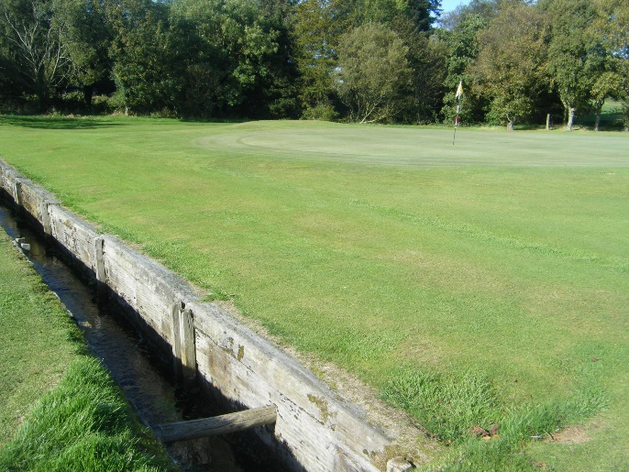
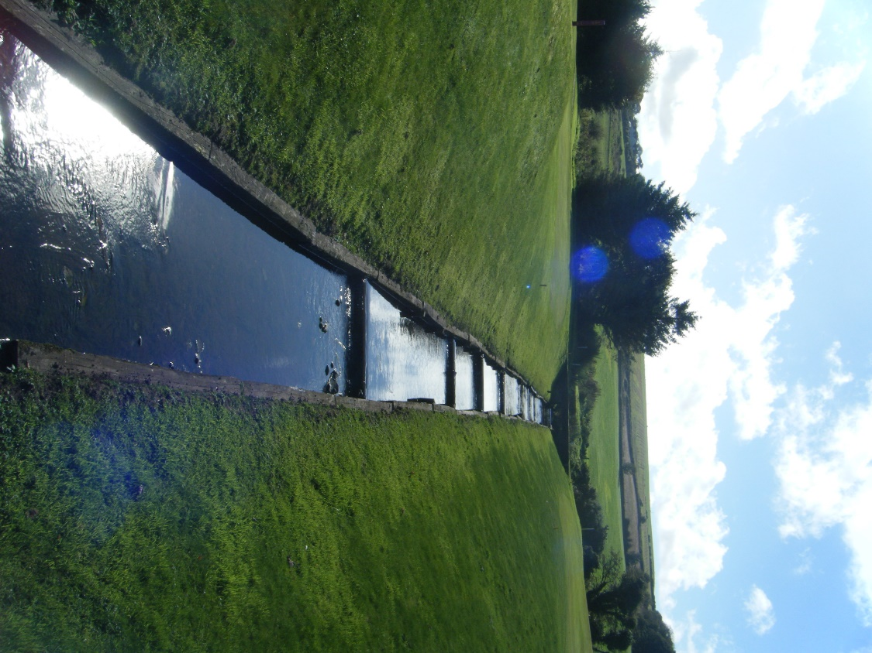
Lack of finance has meant lack of repair to the burn banks and as many have noted there has been a sleeper collapse on the 3rd and 12th holes. The 12th burn has been repaired however a long term solution is required and it may mean totally reconstructing the burn banks on the course similar to that of the 15th and 16th holes. This will visually impact the look and also the play of the 2nd, 3rd and 12th if this is carried (in my opinion for the better).

Fairways and Tees
There is regular divot filling on the tees however we need to have another fairway divot filling day in early June. We are currently investigating the costs for putting artificial turf on some of the winter teeing areas i.e. 5th, 7th, 9th 10th and 12th.

5th Path
After receiving various quotes and reports on the best way of improving the safety of the 5th tee to fairway footpath many of which were out of reach budget wise, Andy Gibson has volunteered to carry out the work at material cost only (a very generous offer) under the banner of sponsorship, this will see our first permanent hole sponsor signage on the course.
Hole Sponsorship
Hole sponsorship has been banded about for a number of years, hopefully this year will see it happen. We are proposing to replace the bin tee signage on all the tees indicating the hole information and a sponsor name. Initially, the Club’s seven main sponsors will all be advertised on the tees, with hopefully the remaining 11 holes adorned with sponsorship (if interested see Davie Gladstone £50 per hole).
At the Bar
Hot Water and Heating System
The current system is many years old and it has been challenging to maintain, there have been a number of breakdowns over the winter. It is proposed to initially replace the boiler (complete with 10 year guarantee) and seek costs on extending the heating system to the ground floor. There are long term heating cost savings with this approach coupled with improving the draught insulation within the premises.
Grant Funding Bids
AS resources are tight we are looking to obtain external income via Funding Authorities and currently we have three funding bids pending, two of these are to improve the Clubhouse facilities and another to enhance playing facilities. We hope to hear more about their progress later, possibly as early as July.
Social Events
Further to an ‘Income Generation’ thematic meeting a number of social and fundraising events have been agreed to progress e.g.:
- Real Ale Beer Tasting Evening
- Car Boot and Home Baking Sale
- ‘Open’ Sunday Club Texas Scramble
- Brass Band Concert
- Scottish Night
There were more than 30 suggestions coming forward from the meeting, many will be held in hand for the future.
Management
The following Committee Members have the following responsibilities, please feel free to approach any of the Committee with feedback and suggestions to improve the Club:
Val Plant – Social Convenor Davie Gladstone – Greens Convenor Andy Gibson – House Convenor

Neville P Wright
N Wright (Club President)

